**ScreenShots:**

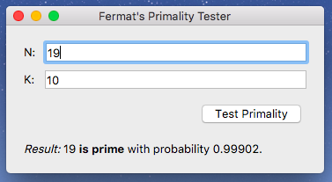

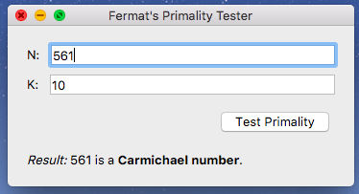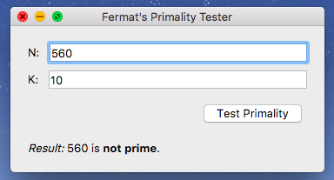

**Code:**

import random  
  
#Project Total Big O = Big O(n^3) + Big O(n) + Big O(k^2) + Big O(k*^2n^3) =

********Big O(k^2*n^3)***********  
  
#Big O(k*(n^2 + n^3) = Big O(k^2*n^3)  
def prime_test(N, k):  
 if(N <= 0): #big O(1)  
 return False  
 else:  
 numbs = list() #big O(1): repeat 1  
 for i in range(0, k): #big O(1) repeat k  
  
 #Get a random number that haven't been used before  
 rand = random.randint(3, N) #big O(N^2)  
 while(rand in numbs):  
 rand = random.randint(1, N) #big O(N^2) repeat k times  
  
 #Tack number onto the list to check for next time  
 numbs.append(rand) #big O(1)

#Check to see if it is a prime number  
 if(mod_exp(rand, N-1, N) != 1): #Big O(n)  
 #If it is not a prime by the Fermat algorithm then its composite  
 return 'composite'  
 else:  
 for j in range(0,len(numbs)):  
 if not(is_carmichael(N,rand)): # Big O(n^3) repeat k times  
 #if is not a carmichael(its a prime) then return prime  
 return 'prime'  
 else:  
 #if not it a a carmichael return that  
 return 'carmichael'

#Big O((n*y^2 + z^2)) = Big O(n)  
def mod_exp(x, y, N):  
 # You will need to implements this function and change the return value.  
 if(y == 0): #big O(1)  
 return 1 #big O(1)  
 z = mod_exp(x, y//2, N) #big O(1) repeat n times (n = bits in y)  
 if(y % 2 == 0): #big O(y^2)  
 return z**2 % N #big O(z^2)  
 else:  
 return x*z**2 % N #big O(xz^2)  
  
 #Big O(k^2)  
def probability(k):  
 # You will need to implements this function and change the return value.  
 return (1- (1/(2**k))) #big O(k^2)  
  
#Big O(y^2 * n + n + n^3) = Big O(n^3)  
def is_carmichael(N, a):  
 y = N - 1 #big O(1)  
  
 while(y % 2 == 0):  
 y = y//2 #big O(y^2): repeat O(n) (n = bits in y)  
  
 result = mod_exp(a, y, N) #big O(n)  
 if(result == 1): #big O(1)  
 return False #big O(1)  
  
 while(result != 1): #big O(1)  
 prev = result #big O(1)  
 result = result**2 % N #big O(n^2): repeat O(n)  
  
 if(N - prev == 1): #big O(1)  
 return False #big O(1)  
 else:  
 return True #big O(1)

**Time Complexity:**

def prime_test(N, k): Big O(k^2*n^3)  
def mod_exp(x, y, N): Big O(n)  
def probability(k): Big O(k^2)  
def is_carmichael(N, a): Big O(n^3)

Thus, the total time complexity: Big O(k^2*n^3)

**Space Complexity:**

List numbs: (kN)

Recursion of mod_exp() (log(y)*4N)

Probability() (3N)

Is_carmichel() (7N)

Total: (kN+log(y)*4N+3N+7N)

**Probability Equation:**

If N is prime, then a^N = 1 (mod N) for all a < N.  
If N is not prime, then a^N=1 (mod N) for at most half the values of a < N.

Thus, the probability of not getting a prime is ½ and the probability of getting a prime is 1 – 1/2. If you try k times then the probability become 1 - 1/(2^k).